C-BIG Reports Training Guide
PULLING C-BIG REPORTS USING SMART VIEW AND WEB APPLICATION

Office of Academic Planning & Budget
Updated August 2021

Contents

CBIG Reports - Training Guide 3
1. Smart View Reports - Training Guide 3
a) Smart View Overview 3
b) Installing Smart View 3
c) Set Mandatory Report Preference on Web First 3
d) Connecting to Financial Reports in Smart View 4
2. Web Application Reports - Training Guide 9

CBIG Reports - Training Guide
This training guide has been created to enable users to take advantage of the data and analysis functions available in C-BIG through the Smart View Excel add-in and Web Application. It is encouraged that users follow along with the steps and replicate what is presented in the manual. If any questions come up during your review of the information, please feel free to contact APB at apbcbig@ponet.ucla.edu, or contact someone from the APB Financial Analysis & Decision Support Team.

1. Smart View Reports - Training Guide

Smart View Overview
- Microsoft Office add-in for Oracle Hyperion Planning applications
- Allows users to input data through templates created for C-BIG
- Provides ad-hoc query capability to users in a familiar Excel environment
- Allows users to dynamically access the live data and develop their own queries
- Allows users to pull CBIG reports to manipulate in Excel

Installing Smart View
If you don't already have Smart View installed, then please refer to links #1 Installing and Updating Smart View and #2 Latest Smart View Version found under the C-BIG Resources section on APB’s C-BIG webpage.

Set Mandatory Report Preference on Web First
A preference option must be set by each user to pull reports – otherwise an error will occur. If the preference has already been set, you may leave as is.
- Log into the CBIG web application (click here to launch)
- After you log into the application, click the Reports icon shown below.
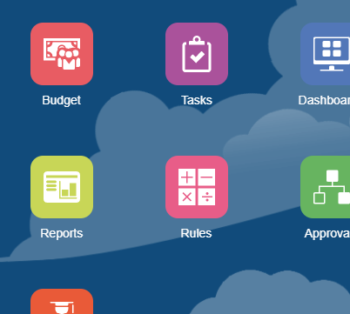

- Make sure that the check box next to “Show POV Options” is selected
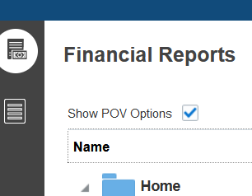

Connecting to Financial Reports in Smart View

C-BIG reports can be pulled into Excel sheets to allow formatting changes and manipulation. Reports can also be opened in HTML view or PDF view through the Hyperion Planning web application. If interested in pulling reports on the web instead, then please refer to section 2. Web Application Reports – Training Manual found at the end of this document.
To open a report in Excel via Smart View,
- Click on the Smart View Ribbon.
- Click on Panel.
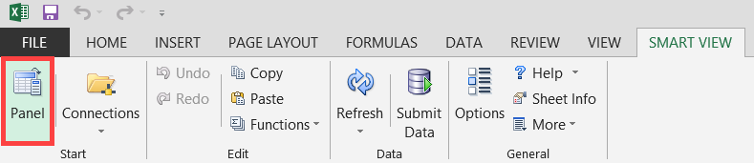
- In the Smart View panel, click on Shared Connections.
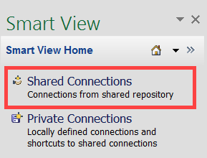
- Enter your User Name and Password and click Sign In:
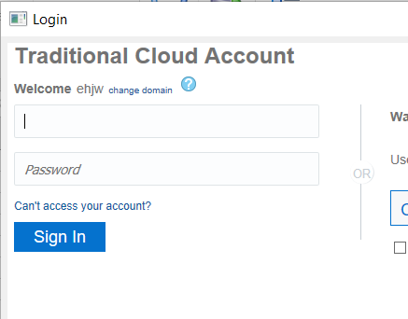

- Open the Smart View Connection panel and select Reporting and Analysis Framework:
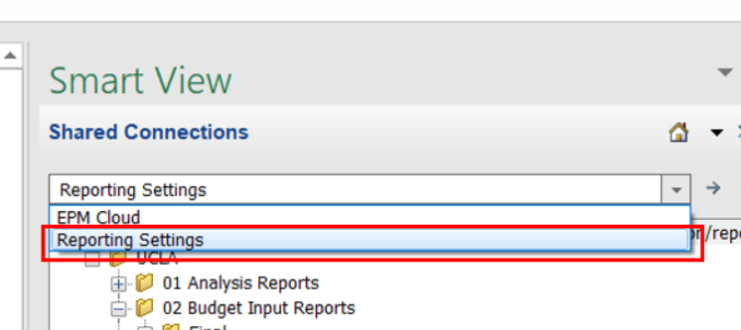
- Click on the + next to the UCLA folder to see the available reports.
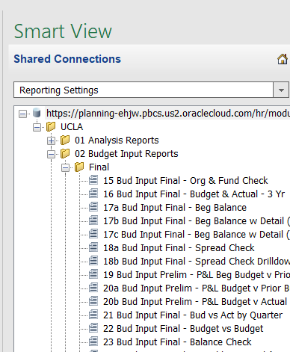
- Open reports by double clicking on the report name found in two separate folders:
  - 01 Analysis Reports: Reports used to analyze data throughout the year
  - 02 Budget Input Reports: Reports to be used during the budget input process
    - The Prelim folder is used during the annual budget input process. The Final folder is used after year end for the adjusted budget process (for any material changes to your original budget submission).
- Review the Respond to Prompts box (not every report has this) and select the desired member for the report. To modify the default elements, open the Member Selection dialog by clicking on the icon that resembles a magnifying glass, highlighted in red.

Users do not have access to the following upper level entities: UCLA OPERATIONS, loc_4, etc. They must be changed to a department or org that they have access to. Use the following formats in the User Point of View window: dpt_#### or org_####.

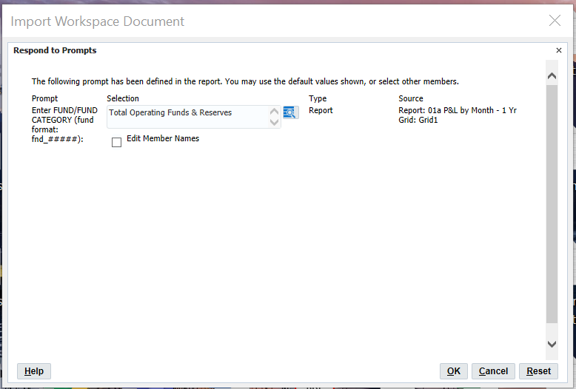
- Next, the Prompt box will appear (if the report has prompts built into it); select one member or multiple members. To select members, click the member selector icon and move the desired members to the right panel (you may need to scroll to see the right panel).
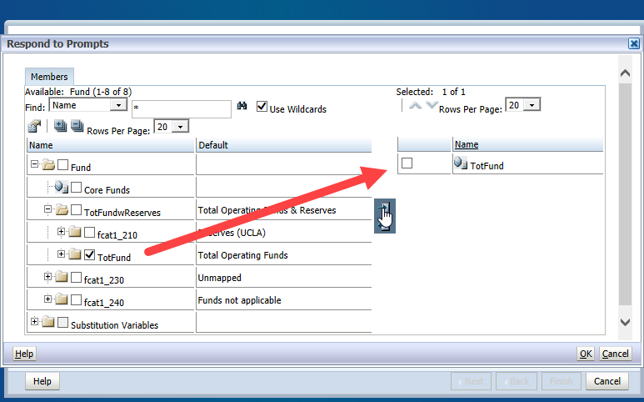
- Alternatively, enter the fund number in the format “fnd_######” into the prompt box. Be sure to check Edit Member Names first (if needed).
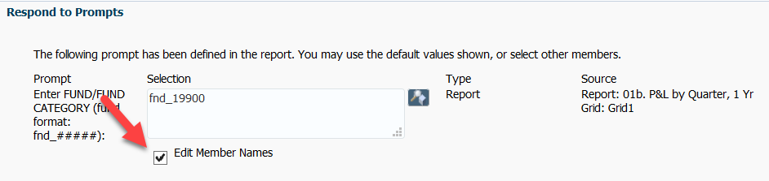
- Click OK after selections are made.
- Preview the report. Choose Fully Formatted under the Import Document As option.
Fully Formatted will give you the report as it was built – font formatting, indents, and borders included! You may change the format of the report after it runs as well.

- Check All Pages if you have multiple Prompt selections to see separate reports for each selection.
- Check Split Pages across worksheets if you would like to see each Prompt selection on a different sheet.
- Click Finish.
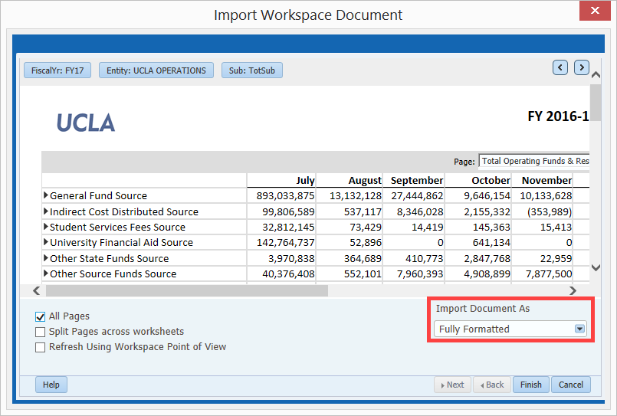
- The report will open in Excel, and users can change the formatting to their liking. Once changes have been made, it can be saved as an Excel file or PDF.
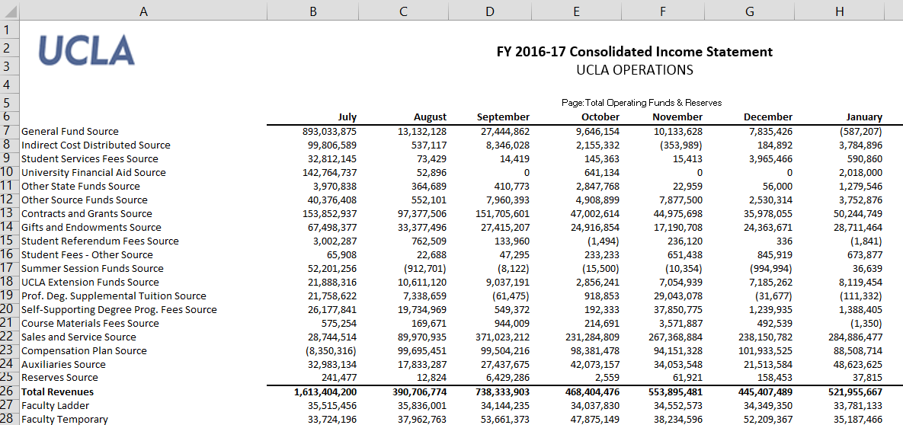
Reports pulled into Excel may need some formatting such as adjusting the column widths or row heights, or positioning the text boxes.

2. Web Application Reports - Training Guide
- Log into the CBIG web application (click here to launch)
- After you log into the application, click the Reports icon shown below.

- Make sure that the check box next to “Show POV Options” is selected

- Click on the next to the Home>UCLA folder to see the available reports.
  - 01 Analysis Reports: Reports used to data financials throughout the year
  - 02 Budget Input Reports: Reports to be used during the budget input process
    - The Prelim folder is used during the annual budget input process. The Final folder is used after year end for the adjusted budget process (for any material changes to your original budget submission).
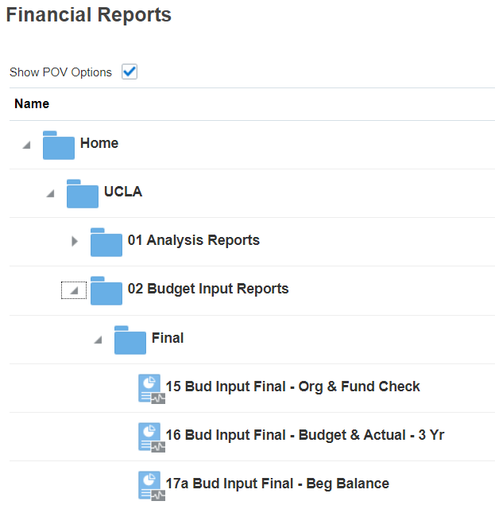
- Open a report by selecting the format under the Actions column: HTML, PDF, or Excel
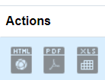

- Review the window prompt to confirm the member selection criteria. Click on the icon to change the member selection:
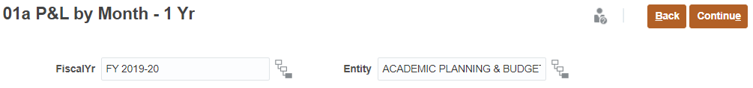

- Review the Select a Member box and select year/entity and click OK:
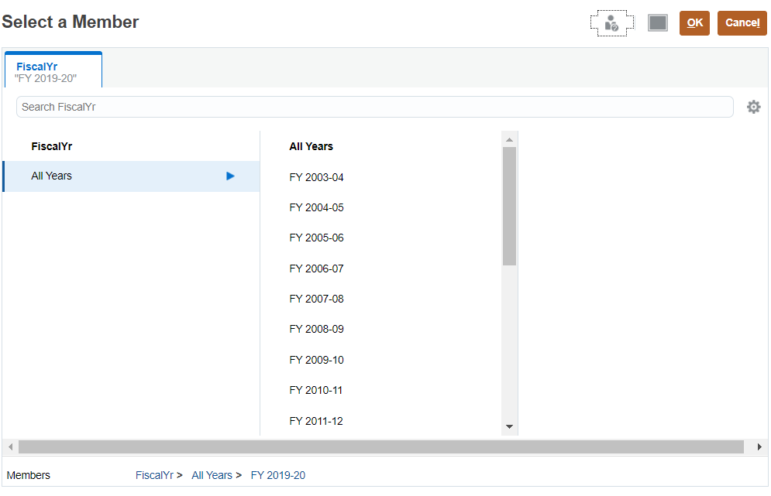
- Once you have updated the member selections, click on Continue to run the report: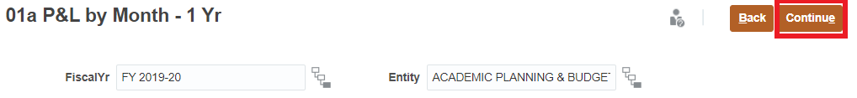

- Review the Respond to Prompts pop-up window (not every report has this) and select the desired member for the report. To modify the default elements, open the Member Selection dialog by clicking on the icon that resembles a magnifying glass, highlighted in red.
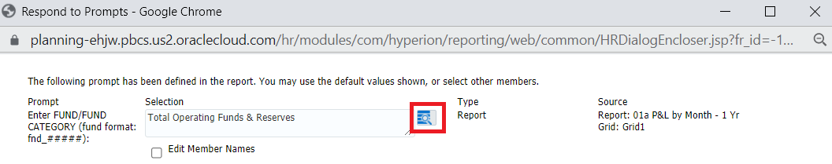
- Next, the Prompt box will appear (if the report has prompts built into it); select one member or multiple members. To select members, click the member selector icon and move the desired members to the right panel (you may need to scroll to see the right panel).
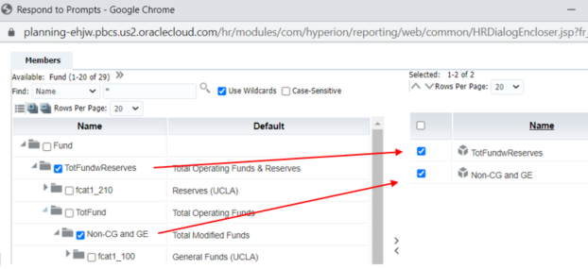
- Alternatively, enter the fund number in the format “fnd_######” into the prompt box. In order to do this be sure to check Edit Member Names first.
- Click OK after selections are made.
- If running the report in HTML, you will be able to drill down for additional detail for some of the rows by clicking the grey arrows seen in the screenshot below.
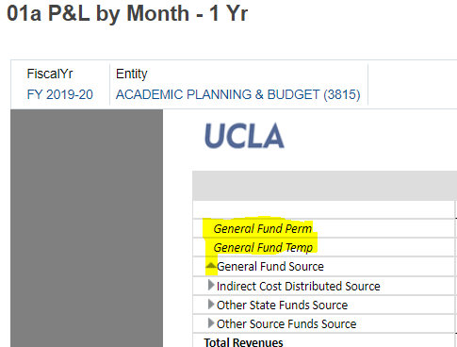
  - If you chose to run the report as a PDF, you will be able to preview the report within the web application prior to downloading.
  - If you chose to run the report in Excel, then the Excel file will automatically download after clicking OK in the prompt selection pop-up window. Users can then change the formatting to their liking in Excel

- Check All Pages if you have multiple Prompt selections to see separate reports for each selection.
  - When viewing reports in HTML, you should see a drop down menu at the top of the report that will allow you to view the data based on the various prompt selections you selected.
